Steps used in individual PYTHON programming:
- Using Keyboard Input for input n.
- Using looping structures (for , while looping structure (DO THE SEPARATE LOOPING STRUCTURE))
QUESTION: Write the PYHON programming to input n and print the following programs:

- (Input ‘r’ also)
- (Input ‘r’ also)
- (Input ‘r’ also)
- n! (Where ‘!’stands for FACTORIAL SYMBOL)

1. Using Keyboard Input for ‘n’.
2. Using looping structures (for, while looping structure (DO THE SEPARATE LOOPING STRUCTURE))

To fine sum the following:

- 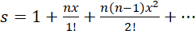 n (Input ‘x’ also)
- 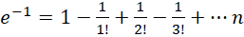
- 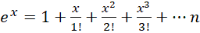
- 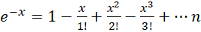
- 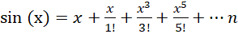
- 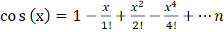
- 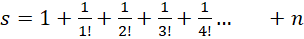
- 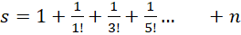
- 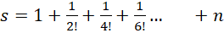

To print Fibonacci number

- 1 , 1, 2 , 3 , 5 , 8 …… n

To sum of Fibonacci number

- 1+ 1+ 2 + 3 + 5 + 8 …… n

